Future Explore IoT Intelligent Dialogue System

Introduce
Building a Smart Voice Control Device from Scratch - Beginner's Tutorial 【bilibili】
The Future Explore IoT Intelligent Agent System is a core operating system for multimodal intelligent devices. Leveraging the MQTT communication protocol and WebSocket streaming dialogue technology, it enables efficient interconnection between devices, intelligent agents, and apps. It supports full-scenario intelligent applications such as voice interaction, device control, and scheduled reminders.
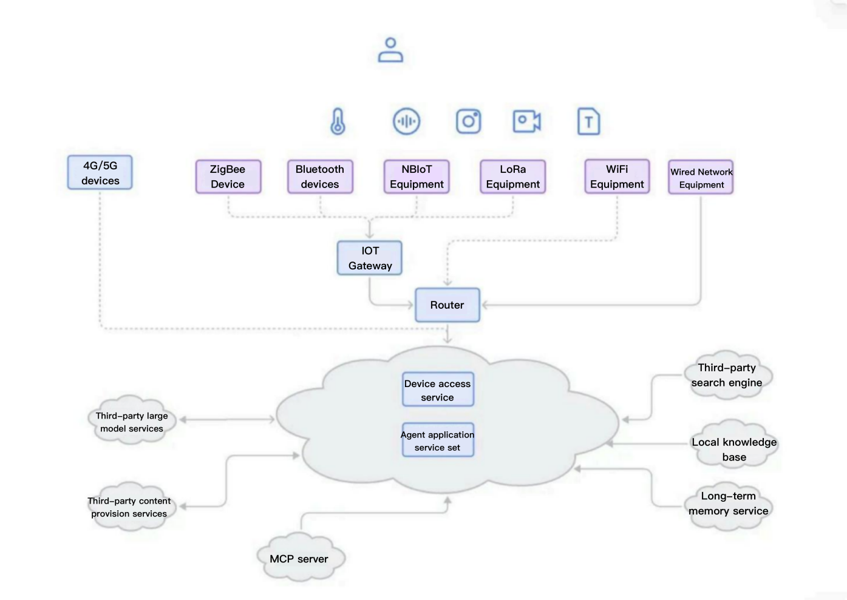
Imprint
Version Information
The current stable release is v2.x.
Key features include complete WebSocket streaming dialogue interaction and MQTT device management channels.
Core Advantages
Dual-Protocol Collaboration: MQTT handles device management and command delivery, while WebSocket enables low-latency streaming dialogue.
End-to-End Security: Triple protection with device authentication, data encryption, and Token validity control.
Multimodal Interaction: Supports multiple forms of input and output, including voice, text, and scheduled tasks.
Extensive Compatibility: Adaptable to the entire ESP32 series chips and over 70 types of open-source hardware.
Flexible Scalability: Supports custom tool coding, voice parameters, and interaction flows.
Offline Capability: Core functions like local scheduled reminders and basic controls remain available during network anomalies.
Multi-Network Support: Full adaptation for WiFi, 4G/5G, Bluetooth, Zigbee, LoRa, and more.
Offline Voice Wake-up: Supports dual customizable wake words (default: "hi, Lexin").
Dual-Protocol Communication: WebSocket for streaming dialogue + MQTT for device control, ensuring real-time interaction and stable communication.
Multimodal Interaction: Full-process voice dialogue based on ASR speech recognition + LLM intelligent reasoning + TTS speech synthesis.
Smart Device Control: Supports various hardware operations like volume adjustment, light control, and scheduled tasks.
Cross-Device Compatibility: Adaptable to multi-chip platforms such as ESP32-S3/C3/P4 and Guoxin Micro.
Multi-Language Support: Switching between 30+ languages including Chinese, English, and Japanese, suitable for global scenarios.
Low-Power Design: Automatically enters sleep mode after one minute of inactivity to reduce energy consumption.
Flexible Configuration: Supports web-based customization of wake-up words, voice roles, scheduled tasks, and other parameters.
Stable Reconnection Mechanism: Automatically retries 1 second after WebSocket disconnection to ensure connection reliability.
Supported Hardware
GX8006 chips and matching development boards.
Espressif official development boards: e.g., ESP32-S3.
Custom development boards: Any hardware equipped with ESP32-C3/S3/P4 chips and featuring microphone, speaker, and Wi-Fi/4G connectivity capabilities.

